Introducing Magic Colony
Josh Bennett
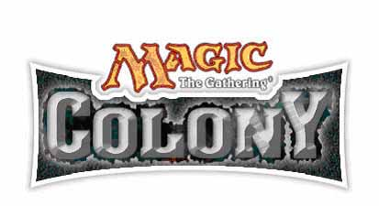
It's The Grand Experiment. Magic meets MTV's The Real World. It's crazy, but just crazy enough to work. Eight Magic players whose skills are matched only by their relaxed attitude towards preparation. One house in the middle of nowhere. One month to break the Odyssey Block Constructed format wide open.
In the bustling environs of Wenatchee, Washington they'll hide themselves away, emerging only to play at Grand Prix-Tampa. None of them are known for their Constructed skills. Just look at their resumes. If all they need to do is show up, they can play with the best of them. All too often, however, they've just taken whatever Constructed deck was handy, and their finishes reflect that. With Pro Tour-Osaka on the horizon, they decided they had to do something.
The putting in of actual effort was daunting. Fortunately, they're not guys who'll do something halfway. For them, the solution was simple. If preparation was what they needed, then they would engineer a place where they would be forced to game 24/7. Free from distraction, they could pour all their effort (usually reserved for carousing) into the design, testing, and tuning of decks.
The commitment was too much for some. Dan Clegg, Brock Parker and William "Baby Huey" Jensen were all tapped for The Colony but turned it down. It's understandable. A month is a long time, and there's always a chance that it won't work out. Will they be able to stand one another? Will they break the format? Or will this well-intentioned month-long frat-party turn into another Animal House? Let's take a look at the players.

Chris Benafel (119 Lifetime Pro Points, Lifetime Earnings $111,600)
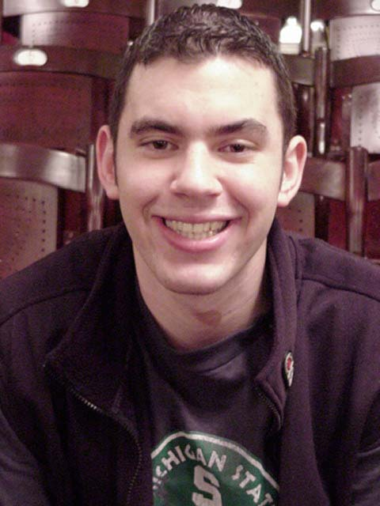
Everyone knows Chris Benafel, with his trademark shifty smile and all-too easygoing nature, not to mention his cautious pace of play. The real reason he's known, however, is his string of top finishes, most recently second place at the New Orleans Masters. Before that, he conquered the Team Limited Grand Prix Circuit with Team AlphaBetaUnlimited. If the Colony can unearth a quality deck, Benafel will be able to run with it. He did the same last year at Tokyo, finishing fourth.

Brian Hegstad (48 Lifetime Pro Points, Lifetime Earnings $45,400)
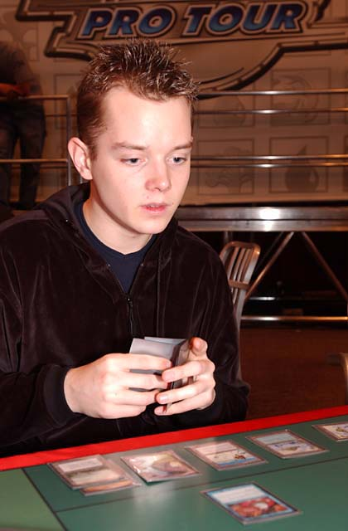
The mild-mannered balance to this often madcap group is Brian Hegstad. He rose to the public eye as he helped the U.S. team continue its dominance at Worlds this year, while at the same time usurping Brian Kibler's place as the Pro Tour's dreamboat. A popular Fantasy PT pick, many expect to see a Pro Tour Top 8 from him in the near future. Could Osaka be his time to shine?

Ken Ho (37 Lifetime Pro Tour Points, Lifetime Earnings $7,150)
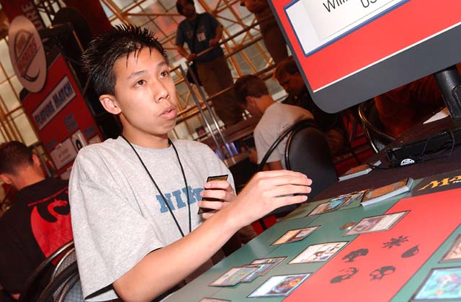
Three Top 32's put Ho ahead in the race for Rookie of the Year last year, but his mediocre performance at Worlds was outshined by that of Katsuhiro Mori, who took the title. A North California player under the tutelage of Ben Rubin and Dan Clegg, the fact that Ho is only just getting started speaks volumes.

Peter Szigeti (25 Lifetime Pro Points, Lifetime Earnings $4,000)
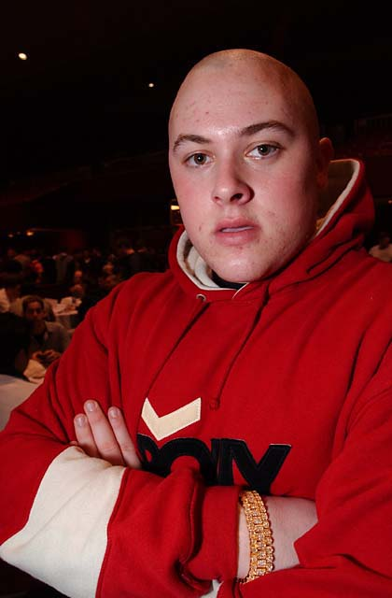
Self-styled master criminal Peter Szigeti tasted success with Parker and Clegg at Grand Prix-Columbus, validating his choice to pursue Magic over College Baseball. Reportedly crushed by Gary Wise's Top 16 finish at San Diego to remain on the gravy train, it remains to be seen if Szigeti will be able to put his feud on hold and knuckle down to the task at hand. They say that living well is the best revenge, and Szigeti does love revenge.

Brett Shears (17 Lifetime Pro Points, Lifetime Earnings $3,550)
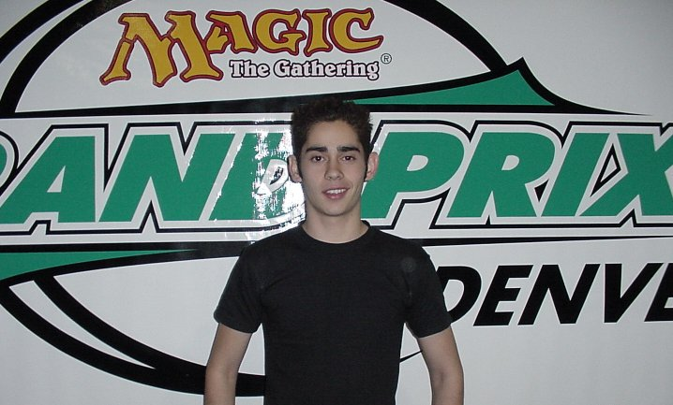
Though he's the low man on this Tower of Power, Brett Shears is no slouch. He played his first Constructed tournament in two years at Grand Prix-Denver, and walked out champion. Seeing a trend here? Shears is another who has the skills, but just needs the right tools.
Those five are the known quantity. With many trips to Asia under their belts, they're no strangers to the troubles of forced cohabitation. Rounding out their group of eight are three of Canada's Best, and though they're all friends, they may not be able to handle a constant barrage of Benafel and Szigeti.

Terry Tsang (93 Lifetime Pro Points, Lifetime Earnings $21,783)
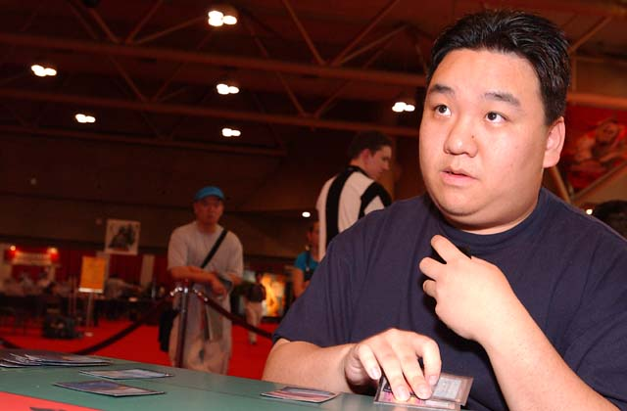
Leading the Canadian connection is graybeard Terry Tsang, with Pro Tour Top 32's going way back. Age hasn't dulled his abilities any, though. He stormed the gates at San Diego to finish in the Top 16. Don't let his ordinarily goofy grin fool you. He's got a mind like a steel trap. Years of working as a computer programmer have given him a knack for analysis.

Jeff Fung (47 Lifetime Pro Points, Lifetime Earnings $15,933)
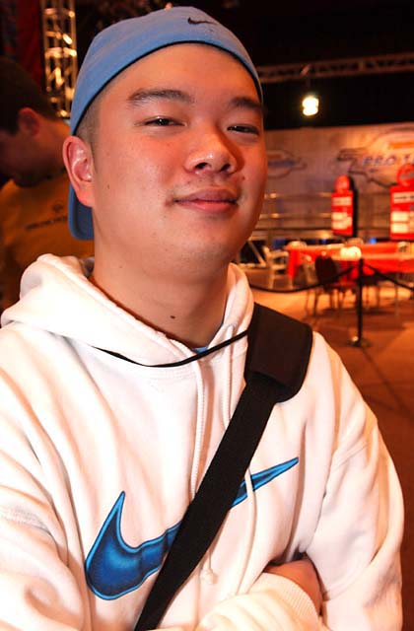
After falling off the train following his monster Top 4 finish in Chicago, a win that had many touting him as The Next Big Thing, Fung was absent from the pro scene for a year. He came back with a vengeance at Grand Prix-Hong Kong, climbing to the Top 8 alongside his Colony cohorts before deftly taking the title. He showed that his return was no joke in San Diego, where eighteenth place tucked three grand in his pocket. Now he's on a very real run to reclaim his place on the train.

Jeff Cunningham (33 Lifetime Pro Points, Lifetime Earnings $12,030)
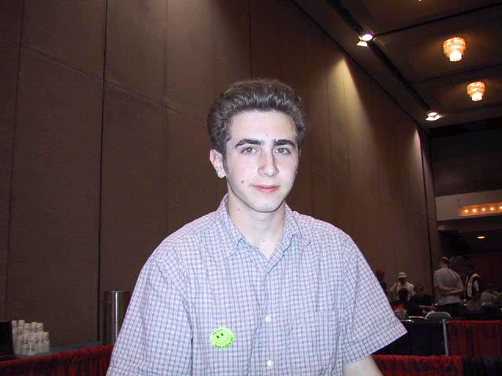
With two Top 32's and now a Top 8 at San Diego, it's no wonder The Colony wanted Cunningham. He leapt at the opportunity, taking a much-needed break from film school. This affable japester is also known for his contributions to the humor website MiseTings.
So there you have it. Eight talents. One house. A powder keg of emergent technology. And if they ever need a break from OBC, they can always sit down to draft.
Check back to Sideboard Online for updates of how everything is going at the Magic Colony.

Discuss this article on the message boards.

